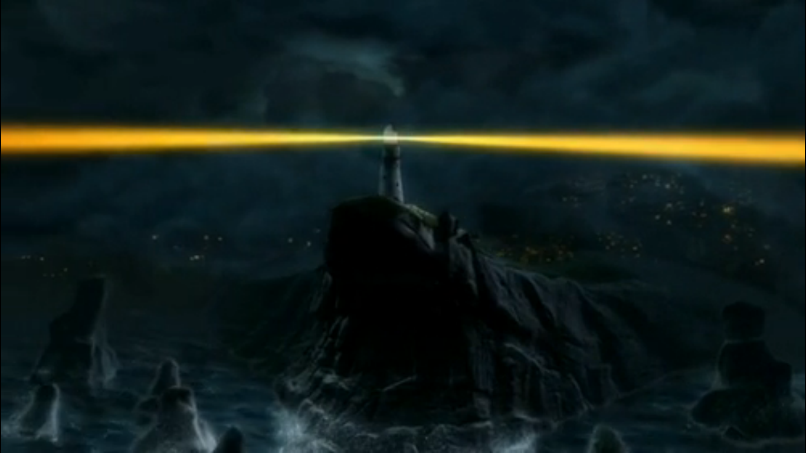

Language to describe setting:

Think about: the time, the weather, the physical environment, sounds, smells, feelings.

The Lighthouse Keepers Answers

Questions to ask the Lighthouse Keeper