Daisy the Donkey’s First Fare.

The author opens the story with:

“Daisy the donkey did not fit in…. she was the only donkey in Saul’s taxi stable, every other taxi was a camel, long legged, long eye lashed and beautifully golden. That was the reason Daisy had never had a fare. She was short, scruffy furred and grey.”

Choose either a camel or Daisy and using the description above, draw what you think they look like.

Daisy the Donkey’s First Fare

In the story Daisy helps Saul by doing various jobs around the stable, what jobs do you do to help out around your home?
In the box below write or draw about what jobs you do or could do to help out around school.

Daisy the Donkey’s First Fare
Comprehension activity
Look at the book again; can you answer these questions fully?

- What is the name of the most popular camel in the stable?

- How does the author describe Daisy?

- Who runs the taxi stable?

- How did the owner get Daisy?

- Why are the other camels all tired?

- Where does Daisy take her passengers?

- What does Daisy use as a saddle?

- Who do you think is born in the stable?

9) At the end of the story, who else is in the stable?

Daisy the Donkey’s First Fare

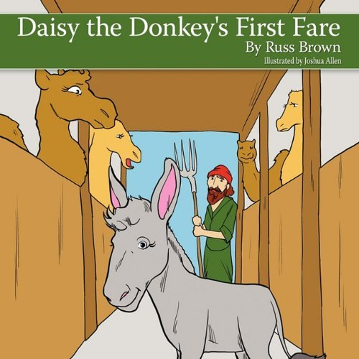

This is the cover of the book; do you think you could create a better one? Draw it below.

Daisy the Donkey’s First Fare
Can you find the hidden words?

p | e | y | r | s | r | t | a | o | f | l | m | h | a | l
t | r | c | p | a | y | e | n | r | u | o | j | r | i | a
c | e | e | l | p | u | o | c | s | e | a | w | c | o | t
r | a | s | g | f | a | a | u | e | s | m | a | f | h | e
h | e | m | r | n | i | h | r | l | i | e | t | a | t | r
o | u | d | e | e | a | y | e | k | n | o | d | c | m | a
s | a | u | l | l | c | n | e | s | l | e | r | a | r | t
e | e | o | o | b | o | t | t | f | i | t | n | r | a | e
t | a | x | i | a | t | g | t | s | a | g | i | m | w | e
e | h | e | l | t | t | d | t | e | e | a | c | e | i | a
o | t | v | c | s | a | o | o | r | o | i | b | l | a | a
d | t | n | l | i | e | o | o | d | c | u | s | v | f | n
e | r | t | s | t | r | t | o | e | j | k | s | y | e | h
a | e | y | h | r | i | e | t | o | t | o | w | a | t | s
e | a | e | r | r | i | e | s | n | a | e | s | a | d | d
Pregnant Journey Donkey Carmel Stable Couple Manger Warmth Daisy Camel Happy Saul
Taxi

Daisy the Donkey’s First Fare
By Russ Brown

Guided Reading Teachers Planning and Activities Pack

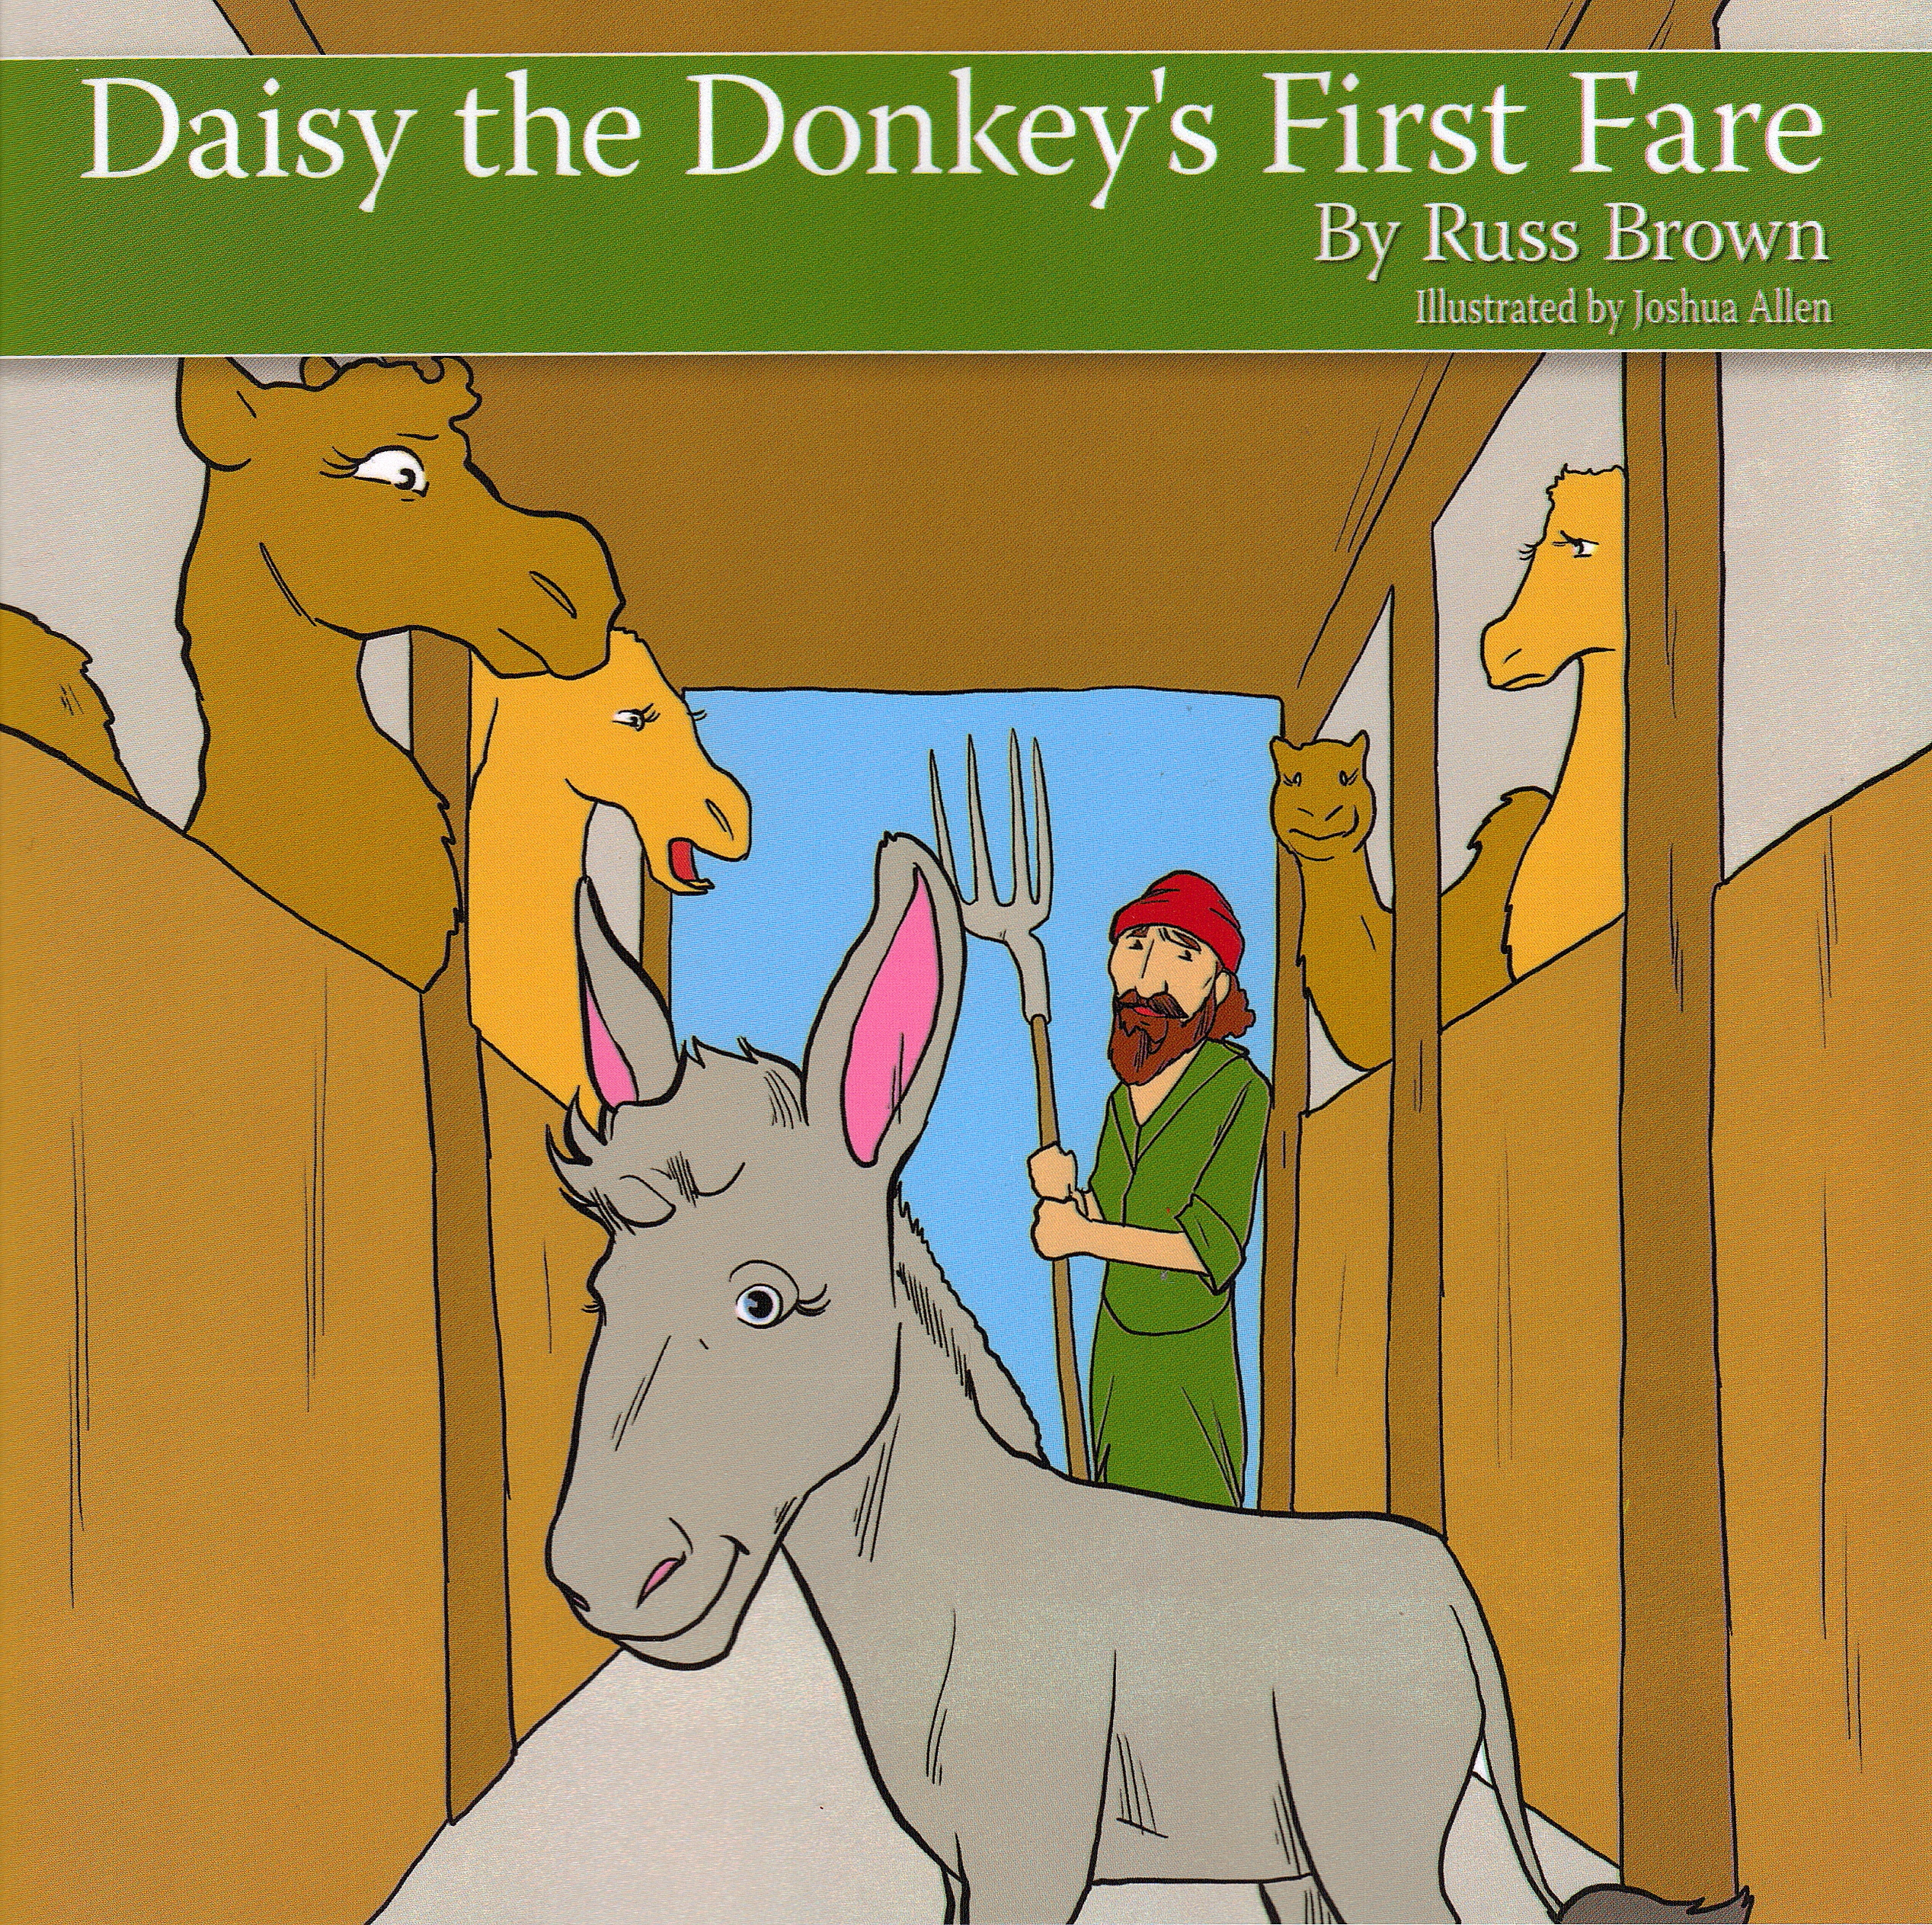

ISBN 978-1-4567-7323-6
Daisy the Donkey’s First Fare Can you storyboard the events of the story? You can write a sentence to go with it | 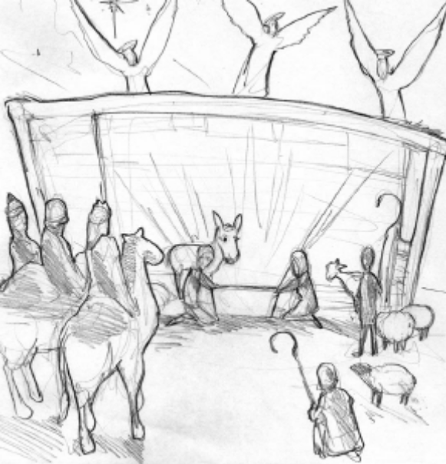
 | 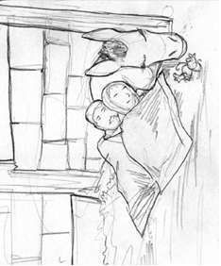
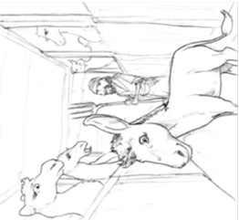
Animal Alliteration

Daisy the Donkey uses alliteration as the “d” sound is used in Daisy and Donkey.
Can you think of any other animals that you could give names to?
Here are a few to start you off. Draw a picture of the character in the box.

Sam the ______________

____________the Giraffe

Maureen the ___________

_______________the Cow

Design a Christmas Card featuring
Daisy and her friends.

Some sketches

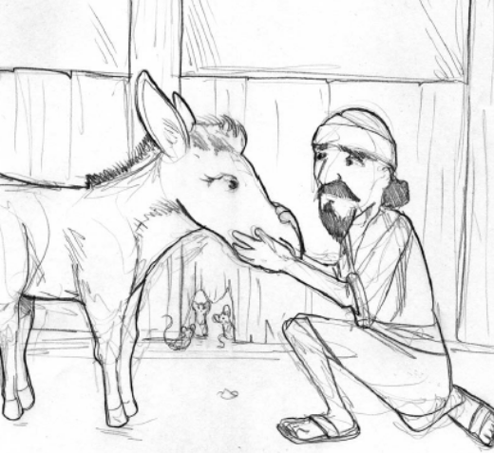

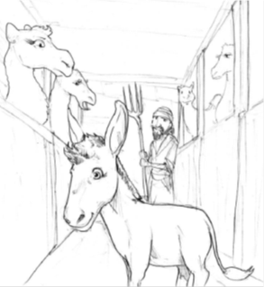

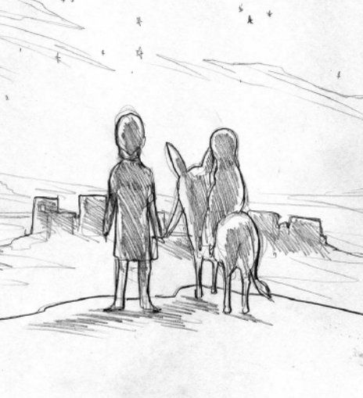

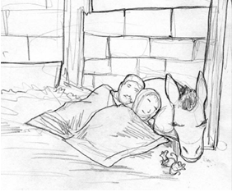

Daisy the Donkey’s First Fare

Try these questions about the book; use the letters to help you.

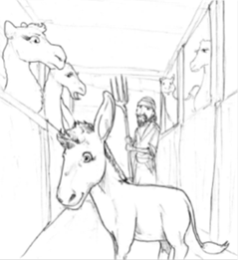
- Daisy is a d _ _ _ _ _.

- Her owner is called S _ _ _.

- Carmel is a c _ _ _ _.

- Daisy is g _ _ _ in colour.

- Daisy has to ride to B _ _ _ _ _ _ _ _.

- They spend the night in a s _ _ _ _ _.

- In the manger is a beautiful b _ _ _.
Bethlehem, grey, Saul, camel, donkey, stable, baby

Teacher’s resources

Thank you for purchasing Daisy the Donkey’s First Fare. I have created this free resource pack to enable you to use the book to its full potential. As a teacher I wrote it for KS1 early KS2 children. I think it works as a book on a number of levels and have provided some activities which could be incorporated into your planning. I hope you find it useful and if you create any resources in relation to the book let me know and I could add it to this pack. Contact me via: www.russbrownauthor.co.uk
Thanks
Russ

Literacy:
Writing & Guided reading activities.
Cloze procedures, using words from the text to complete sentences the words can be given or allow the children to scan the text to find the correct word.

Story board the story, this can allow the children to fill in the story using relevant pictures in order, or the children could have a mixed up picture story board and be asked to sort it.

Writing the story from the viewpoint of the couple who use Daisy.

Create a list of animal alliteration, Daisy the Donkey, Carmel the Camel. What other names can the children think of?

Story writing write another famous story from a different viewpoint, imagine being the dove on the Ark, a servant in the palace for Cinderellas ball, a soldier at the fall of humpty dumpty get the children to look at the insignificant characters in famous stories do they change the story we love and know, (this could be in the form of a shared write.)

Comprehension The children can be asked direct questions from the text and can also use the text to answer questions such as the author describes Daisy as …… can you draw a picture of what you think she looks like?

Spelling and Handwriting Use of word search to develop spelling looking at starting and ending letters. Can the children handwrite a number of sentences from the book? Can we create a spider diagram to list other words in place of said/sadly etc…

Book making In groups the children are given one page can they create a new page written by them (reducing the page to one or two sentences) and a picture. Then all pages can be collated to create a class book. Use the sketches resource and allow the children to create the book again using one or two sentences under each.

Review Once the story has been read and enjoyed and questioned can the children review it? Recall events, favourite character, best part and favourite picture.

Blurb As a class can we write a new blurb for the book, do we like the blurb? Does it tell us enough? Can we write a better one?

R.E.& PSHE
Christianity Christmas the story of Christmas and the birth of Jesus. Can the children retell the story of the birth of Jesus? Can the children create a Christmas Card which includes some of the characters from the book? Why do we send Christmas cards? (History link)

Being helpful When are we helpful? Think about the people who are helpful to us, can we create a poster or write about what helpful jobs people do, around school, outside, at home? Think about those who help us all the time, the Police, Fire and Ambulance services etc… Can the children think of anymore?

The warmth? Question elements of the story, what is the warmth felt by Daisy? Is it love? What does love mean? Who do we love? Why do we love them? Open class discussion activity.

Art
Design a new book cover Can we think of a better picture for the book? The real one does not tell us much about the story can we create a better one?

I know how creative Teachers are and I am sure you can think of more and better ideas than mine today with my book, if you do please let me know and I will add it to my pack contact via : www.russbrownauthor.co.uk

