+

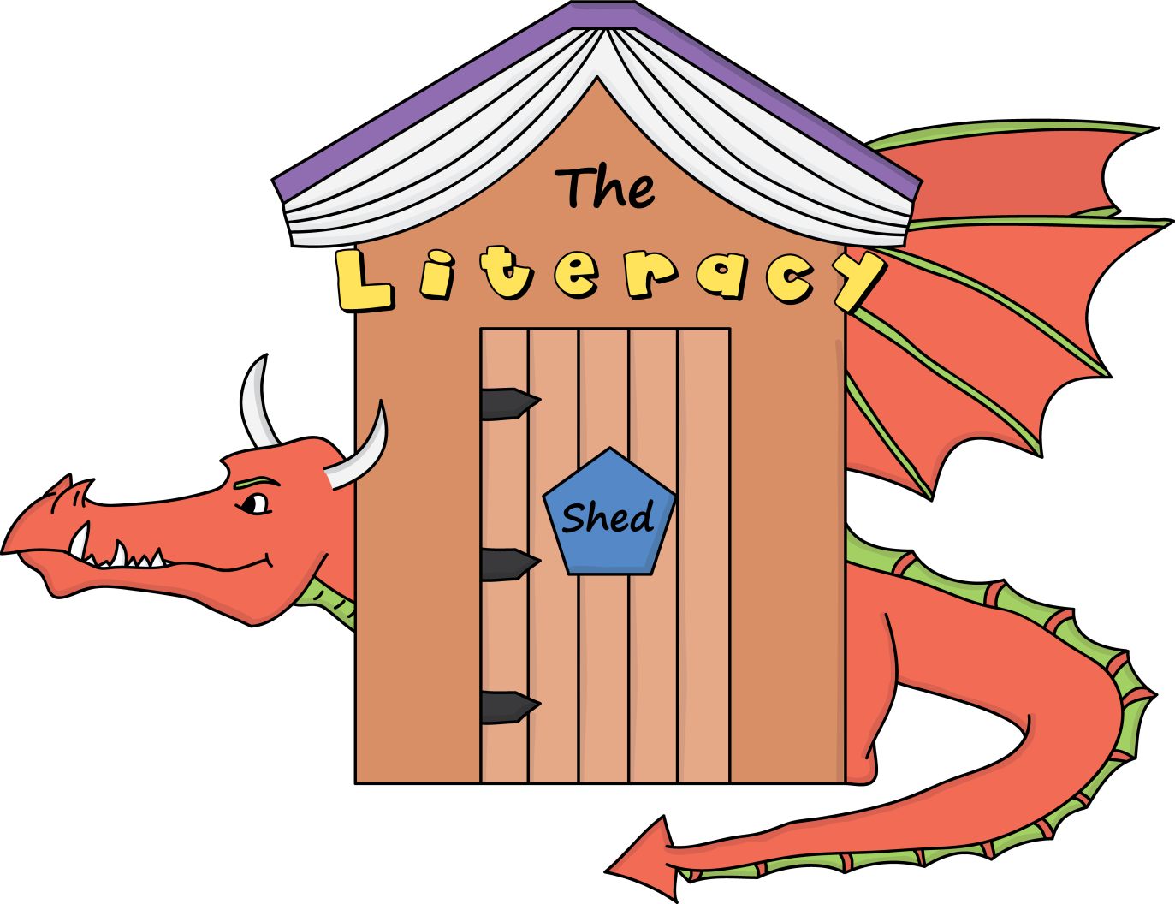

**The Literacy Shed is home to a wealth of visual resources and teaching tips to enhance teaching and learning in literacy**.