Year Group: 3 | Teacher: Mr Silver
Unit: Adventure and Mystery | Week: 3 of 3
Unit Outcomes
Phase 3
Children can plan an extended narrative using the key features of the text-type.
Children can write an extended adventure story with logically sequenced events and a resolution

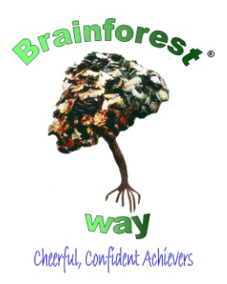

 | Can I..? | Lesson Plan |  |  | Assessment & Next Steps
 |  | - Input  - Activities | - Groupings  - HA Question | - TA Support  - Plenary
Monday  30 mins | Plot an adventure story? | Shared Reading/Writing  Explain that by the end of this week we will have written our very own story based on ‘The Dragon Machine’.  Show children my own storyboard based on the text.  Independent Activity  Children to create a checklist of 6 important plot points that come up in the Dragon Machine. Once this has been done, they should begin to use these points to help them create their own plot and story. What will be the main features? Who will the characters be? Where will they go? How will it end?  Guided group activity  T to work with LA group who will be writing the same story as each other. They must work as a group to come up with their character, plot points etc. These must be written down in a list for tomorrow’s lesson.  Plenary  Show children my own storyboard based on the 6 plot points given in The Dagon Machine. Discuss the key plot points for each story.
Tuesday | Plot my story on a story board? | Shared Reading Writing:  Share the storyboard from yesterday. Show the children a ‘new’ version that draws on all the elements from The Dragon Machine. Explain that some children will be writing in the first person and some in the third person.  Independent Activity  Using the 6 plot points from yesterday, begin to create the new storyboard.  Guided group activity  ET to work with LA group with plotting their 6 features onto a storyboard. This group will be using the same story board. Once they have done it can they begin to tell the story orally?  Plenary  Ask children to begin to tell their story to their partner orally. Can they clearly express each section of the text?
Wednesday | Use a story board to write an adventure story? | Shared reading/writing  Share a pre written story from the example shown yesterday. Discuss in pairs how it draws on the storyboard to help with a clear plot. Explain that each section has become paragraph.  Independent activity  Children to use their story board to begin to write a draft of their new adventure story.  Guided group activity  TA to work with LA- supported composition - write next sentence on a white board – partner offers suggestions for improvements.  T to work with HA table and explain that these children will be writing their story from the first person point of view. Show storyboard from yesterday and model telling the story from the 1st person point of view.
Thuhrday | Give feedback to others? | Shared reading/writing  Discuss what makes good writing. Have the children felt that they have done this over the past week? Do they feel their writing is improving?  Independent activity:.  Children to have a photocopy of another child’s adventure story. Children to use highlighters to show positives and points of improvement within the writing.
Homework Opportunities

