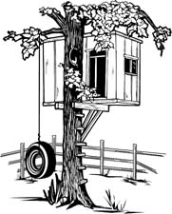
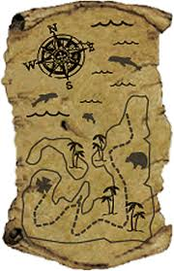
The Adventure Shed Vocabulary List
forest | water | lake | horizon | ugliest | eerie | massive
miniature | freezing | followed | fight | whispered | missing | island
castle | beach | hunter | scattered | fire | lightning | treasure
rowing | storm | camping | vanished | blizzard | stranger | locked
chased | wilderness | torch | escape | immense | scrawny | filthy
shouted | cried | whispered | bicycle | dusty | ancient | treehouse
dusty | eventually | dusk | twilight | meanwhile | broken | chilly
ruins | abandoned | shaft | encrusted | fastened | jammed | unsightly

