**C:\Users\Karen\AppData\Local\Microsoft\Windows\Temporary Internet Files\Content.IE5\H2FE5XLR\MCj01334890000[1].wmfC:\Users\Karen\AppData\Local\Microsoft\Windows\Temporary Internet Files\Content.IE5\H2FE5XLR\MCj01334890000[1].wmfPenguin Websites**

<http://www.penguins.cl/penguins-species.htm>

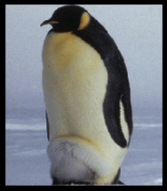

<http://www.kidzone.ws/animals/penguins/facts10.htm>

<http://projects.edtech.sandi.net/encanto/penguins2/>

<http://library.thinkquest.org/J001423/>

<http://warrensburg.k12.mo.us/webquest/penguins/index.htm>

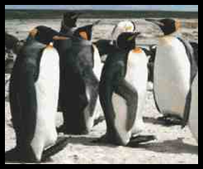<http://www.dembsky.net/penguins/facts.html>

<http://www.dembsky.net/penguins/types.html>

C:\Users\Karen\AppData\Local\Microsoft\Windows\Temporary Internet Files\Content.IE5\H2FE5XLR\MCj01334450000[1].wmf<http://edtech.kennesaw.edu/web/penguin.html>

C:\Users\Karen\AppData\Local\Microsoft\Windows\Temporary Internet Files\Content.IE5\CI2F0G7I\MCj01116020000[1].wmfC:\Users\Karen\AppData\Local\Microsoft\Windows\Temporary Internet Files\Content.IE5\BOLDP8JK\MCj04346010000[1].wmf