The Lighthouse (KS2)  http://www.literacyshed.com/the-lighthouse.html | 2 sessions
Learning Intentions:
- to ask questions based on the animation
- to answer questions in role
- to story board key events of a silent animation.
- add speech/thought bubbles to a silent animation.
- to write an imaginative, descriptive narrative based on an animation.

Activities:
Session 1
Watch the film up the point where the candle goes out. Discuss the setting and the title - let children make predictions about the content.
Children brainstorm language to describe the setting, think about nouns, adjectives and adverbs. [Record on Resource Sheet A]

Watch the remainder of the film. When the Lighthouse keeper breaks the lamp, pause and discuss possible outcomes.
Tell the children that they are going to carry out some hot seating, asking the lighthouse keeper some questions. The children think about the things they would ask the lighthouse keeper about the events of that night.
Record questions on resource sheet A. [No of questions dependent on ability.]
Model hot-seating by becoming the lighthouse keeper or choose a pupil to be the lighthouse keeper.
Children can record some answers to help them remember key points.

With the children record key points or ‘bare bones of the story’ in the form of bullet points.
Children in pairs on A3 to create a ‘comic style’ retelling of the main points with captions and speech bubbles. Adding the Lighthouse keeper’s thoughts and utterances.

Session 2
Some sentence work may be prudent here depending on your class. Collect nouns relating to the story, e.g. sea, candle, lamp etc
Model example; ‘Sea,’ add an adjective, then a verb, then a prepositional phrase, then an adverb to end up with, ‘The sapphire blue sea crashed violently against the sharp, rugged rocks.

Remind the children of the bare bones of the story. Give them 20 – 30 minutes to write a short story based on ‘The Lighthouse.’ Focus on quality not quantity.

AfL To check for descriptive language ask the children to write down the most descriptive sentence in their story. Copy it down onto the ‘Competition entry form’ [resource sheet B]
Pin these to a display board. Each child has a sticker to vote for their favourite sentence. Share the sentences with the most stickers.

Resources: http://www.literacyshed.com/the-lighthouse.html
Resource Sheet A
Resource Sheet B
Appropriate Light Keepers Hat (optional)

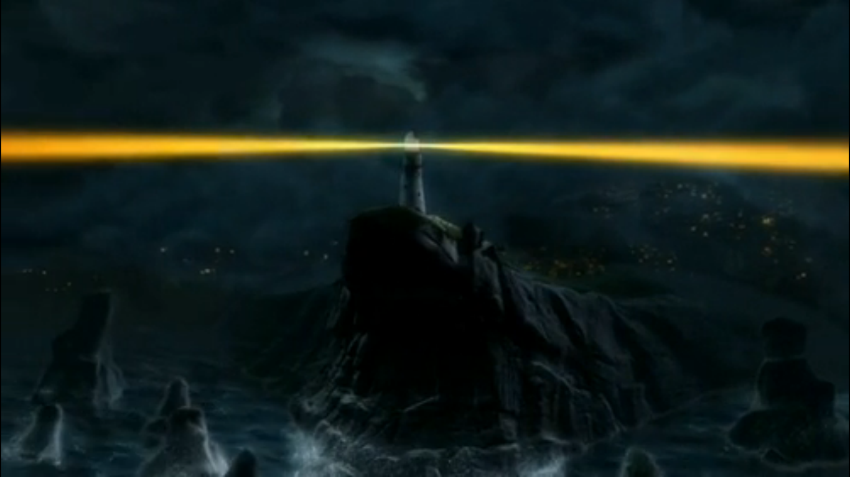
Language to describe setting:

Think about: the time, the weather, the physical environment, sounds, smells, feelings.
Questions to ask the Lighthouse Keeper

The Lighthouse Keepers Answers

My favourite descriptive sentence:
...................................................................................................................................................................................................................................................................................................................................

My favourite descriptive sentence:
...................................................................................................................................................................................................................................................................................................................................

