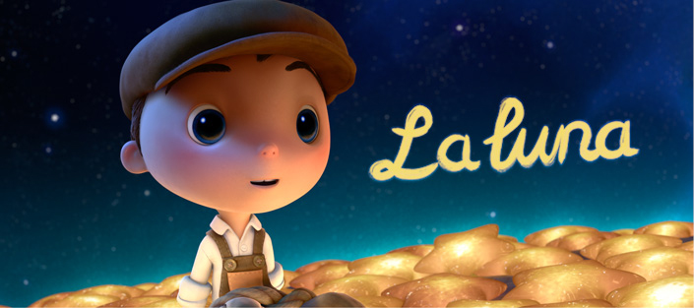
I can answer questions using evidence (and inference skills)

- Who do you think the boy is? Explain why you think this (AF2/3)

(2 marks)
(2 marks)
- Why do you think they are there at night? Give two reasons (AF2/3)

- Why do the two older men try to show him how to wear his hat / clean up? What does the boy think of the two different ways – how do you know? (AF6)

(2 marks)

- Why do you think there is no “speaking” in the film? (AF7)

(3 marks)

- What is the point of the boy turning his hat around and using a rake? What does this tell the audience about the character? (AF3/6/7)

(3 marks)

